1.5 hour exam Tuesday

Short answer questions
Through chapter 5

Charged particle trajectories
Useful for visualizing but not fully self consistent guiding center
Drift velocity
Confinement issues : torus vs. mirror

Cyclotron radiation (plus Bremsstrahlung) = 2 Radiation
“line radiation” from a cold plasma region

Various combination of $\vec{E}$ and $\vec{B}$
$\vec{E}≠0$ $\vec{B}=0$
$\vec{E}=0 \vec{B}≠0$
$$\vec{E}⊥\vec{B}$$
$$\vec{F}=ma$$
q [$\vec{E}+(\vec{V}x\vec{B})]=m \frac{d\vec{v}}{dt}$

Guiding Center $V_{Drift}$
Helicd motion
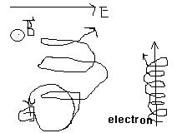
$$V_{Drift}= \frac{\vec{E} X \vec{B}}{B^{2}}$$
$V_{Drift}= \frac{\vec{F} X \vec{B}}{qB^{2}}$ (Equation 5.26 in textbook)
